Q17. Read the following description of an electronic iron equipped with a microcomputer, and then answer Sub-Questions 1 through 3.

Fig. 1 below shows the system configuration of the temperature control section of the iron. The extended COMET controls the temperature of the iron through timer interrupt processing (Interrupt 0) that is generated once per second.

[Description of Iron Temperature Control]
(1) When the heater is turned on, the temperature of the iron rises.
(2) The temperature of the iron is measured by reading the value of the temperature sensor via an A/D converter.
(3) The measured temperature of the iron is compared every ten seconds with the temperature set by a switch. Depending on the result of the comparison, one of the control numbers in Table 1 is selected.
(4) The heater is turned on or off in accordance with the control number that was selected in (3).

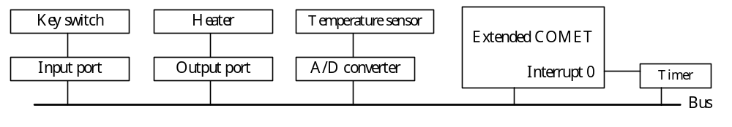
Fig. 1 System Configuration

Table 1 Relationship between Temperature Setting and Control Number
Difference from temperature setting  (Temperature setting - iron temperature) | Control number | Heater ON time at ten-second intervals (seconds) | Rate of change in iron temperature
50°C or higher | 1 | 10 | Temperature rises  10°C / 10 seconds
30°C up to 50°C | 2 | 8 | Temperature rises  8°C / 10 seconds
20°C up to 30°C | 3 | 6 | Temperature rises  6°C / 10 seconds
10°C up to 20°C | 4 | 4 | Temperature rises  4°C / 10 seconds
−10°C up to 10°C | 5 | 2 | Temperature rises  2°C / 10 seconds
Up to −10°C | 6 | 0 | Temperature falls  5°C / 10 seconds

Sub-Question 1
Fig. 2 below shows how the iron temperature was controlled as the temperature setting was changed. Select the correct answers to be inserted into the corresponding boxes ()in the figure from the choices provided.

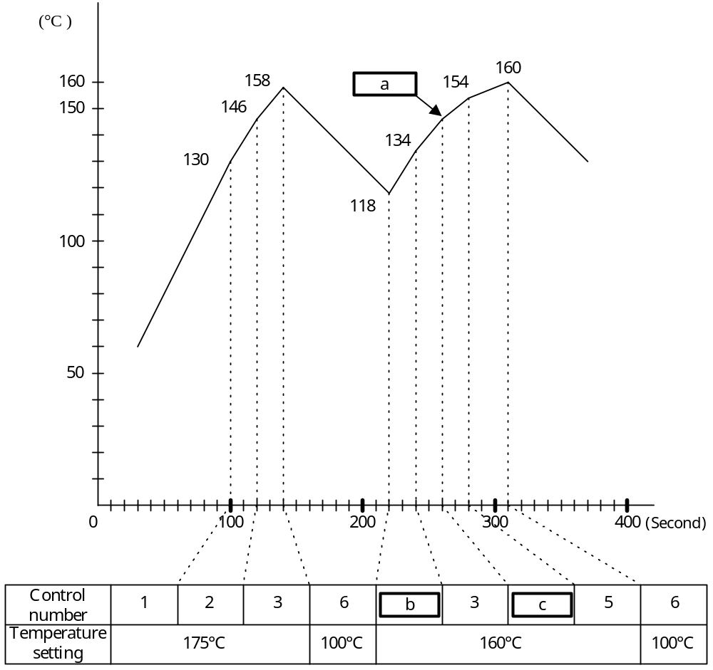
Fig. 2 Change in Iron Temperature

Answer group for a:
A. 143 B. 144 C. 145 D. 146 E. 147

Answer group for b and c:
A. 1 B. 2 C. 3 D. 4 E. 5 F 6

Sub-Question 2
Select the correct answers to be inserted into the corresponding boxes () in the timer interrupt processing flowchart shown in Fig. 3 below from the choices provided.

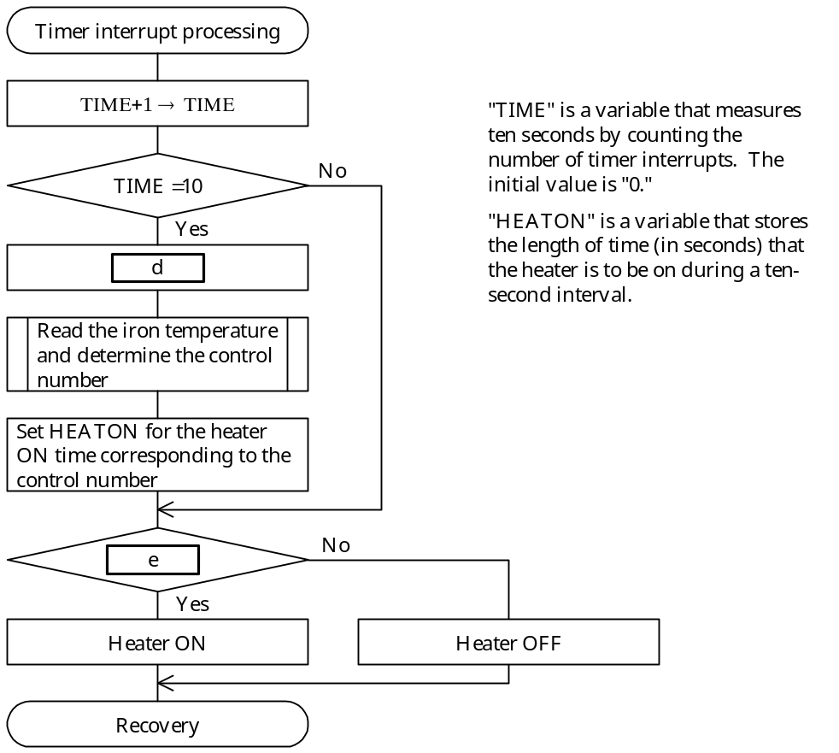
Fig. 3 Timer Interrupt Processing Flow Chart

Answer group for d:
a) 0 → HEATON b) 0 → TIME c) 1 → HEATON
d) 1 → TIME e) 2 → HEATON f) 2 → TIME
g) 4 → HEATON h) 4 → TIME

Answer group for e:
a) HEATON < TIME b) HEATON > TIME c) HEATON ≠ TIME
d) HEATON ≤ TIME e) HEATON ≥ TIME

Sub-Question 3
Select the correct answers to be inserted into the corresponding boxes () in the following description from the choices provided below.

The following functions were added in order to improve the safety of the iron by detecting any abnormality or failure in any of the devices that comprise the iron temperature controller (see Fig.4 below) .
Hardware: A heater controller that turns off the heater if “1” is not written to it within 1.5 seconds.
Software: At the beginning of the timer interrupt processing that is performed once every second, a “1” is output for a constant time to the heater controller that was added.

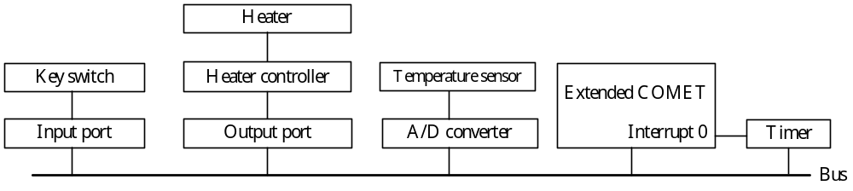
Fig. 4 System Configuration after Addition of Heater Controller

The abnormalities or failures that can be detected as a result of the addition of this function are  and .

Answer group:
a) Degradation of precision in the A/D converter b) Failure of temperature sensor
c) Stoppage of extended COMET d) Key switch failure
e) Stoppage of timer f) Heater failure
Ans: a – D, b – B, c – D, d – B, e – B, f – C, g - E
Sub 1: Sau 20 second, với mức điều chỉnh 3, nhiệt độ sẽ tăng lên 12 độ C. a = 134 + 12 = 146. Đáp án a – D. Sau 20 second, với mức điều chỉnh b, nhiệt độ tăng lên 134 – 118 = 16. Vậy b = 2. Đáp án b – B. Sau 20 second, với mức điều chỉnh c, nhiệt độ tăng lên 154 – 146 = 8 độ. Vậy c = 4. Đáp án c – D.
Sub 2: Sau khi TIME đạt tới 10, nó lại được thiết lập lại cho lần ngắt mới. Đáp án d – B. Nếu thời gian vẫn còn ít hơn thời gian đặt HEADON thì sẽ vẫn còn thực hiện tiếp. Đáp án e – B
Sub 3: Điều kiện để dừng hệ thống là đồng hồ dừng hoặc do hệ thông COMET dừng lại sẽ không tạo ra ngắt.

